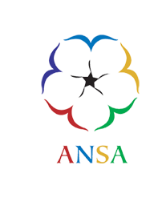
African Nova Scotian Affairs
Emancipation Civic Proclamation

Context:
As Nova Scotia prepares to express recognition for Emancipation Day on August 1st, we are inviting your organization to participate in the acknowledgement and commemorate this aspect of an important historical remembrance.

Also, please be aware that August 23rd is known as the “International Day for the Remembrance of the Slave Trade and its Abolition”. The importance of the day is connected to people of African Descent in Haiti and the Dominican Republic fighting for their freedom which resulted in their liberation from their European colonisers in 1791.

Globally, August 1 honours Emancipation and August 23rd is a remembrance about the tragedies of the transatlantic slave trade in which millions of African descendant people were enslaved or lost their lives.

Defining these events (Emancipation Day and The Day of Remembrance) as a proclamation allows elected representatives the opportunity to read a statement declaring their recognition of these events, which carry the symbolism and the authority of a civic edict.

Intent:

If you are planning a commemorative event, the attached funding application can support your activity up to $500. However, it is urgent you complete the application and forward same to ANSA as soon as possible.

There is the expectation your civic proclamation will be a collaboration/partnership with the community. It is our hope we can work in advance of the date and identify, if required, community partners who might be willing to co-plan an in-person/virtual Emancipation Day Proclamation.

Thank you very much for attending to this important matter.

Sincerely,

Wayn Hamilton
Executive Director
African Nova Scotian Affairs

